**Exercise 6: Cursors**

**Scenario 1: Generate monthly statements for all customers.**

**Question: Write a PL/SQL block using an explicit cursor GenerateMonthlyStatements that retrieves all transactions for the current month and prints a statement for each customer.**

**Cursor Execution and Output  
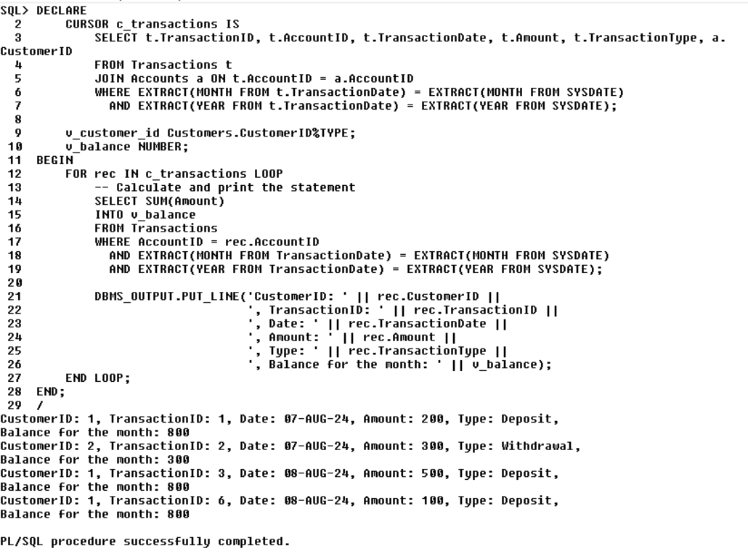**

**Scenario 2: Apply annual fee to all accounts.**

**Question: Write a PL/SQL block using an explicit cursor ApplyAnnualFee that deducts an annual maintenance fee from the balance of all accounts.**

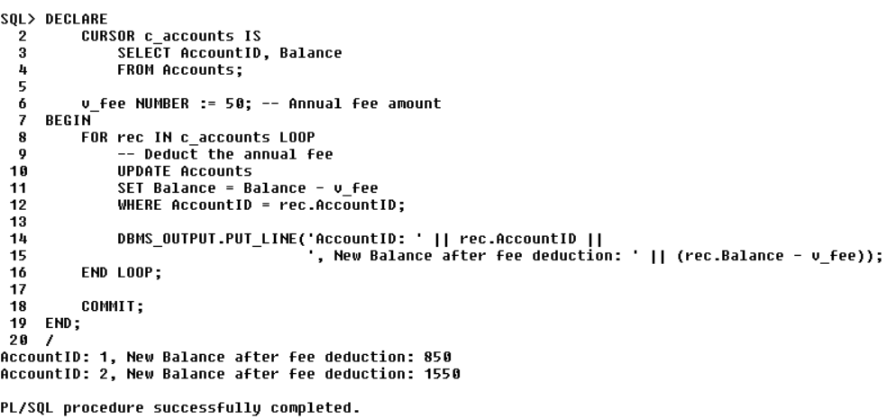

**Scenario 3: Update the interest rate for all loans based on a new policy.**

**Question: Write a PL/SQL block using an explicit cursor UpdateLoanInterestRates that fetches all loans and updates their interest rates based on the new policy.**

Cursor Execution

